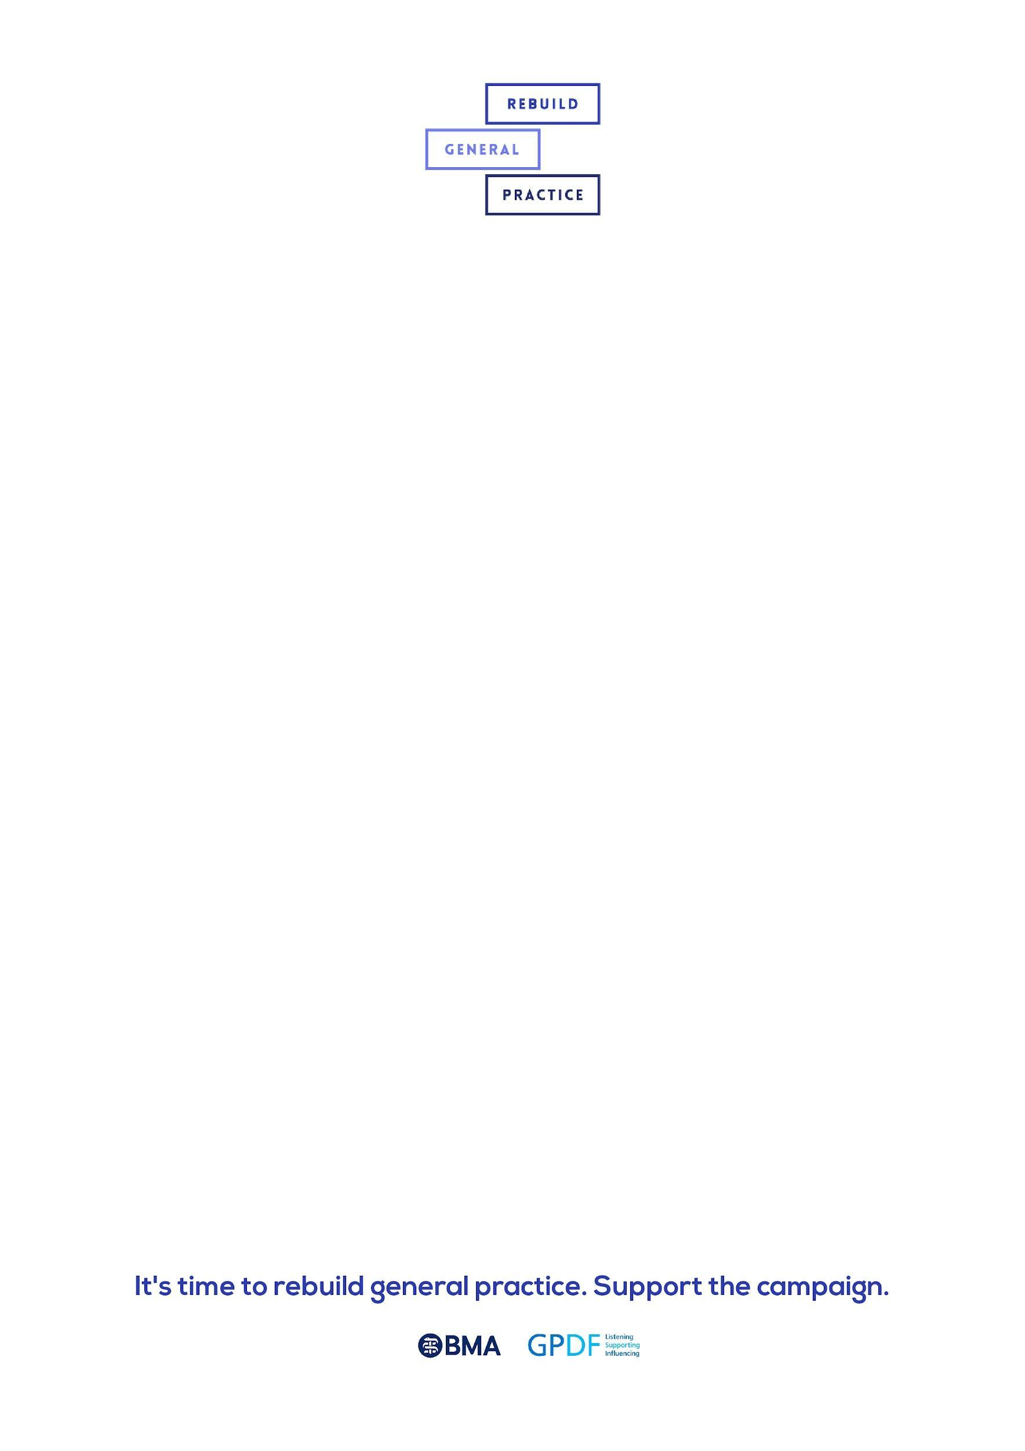**Example tweets to support Rebuild General Practice**

You can also follow @RebuildGP and share content directly.

1)

General practice is in crisis. Patient safety is at risk.

We are GPs from across England, Scotland, and Wales raising the alarm. We must Rebuild General Practice.

#RebuildGP

2)

Years of underfunding and neglect has left general practice in crisis.

There are not enough GPs to meet the needs of our patients.

The system is fractured. Patient safety is at risk. We must Rebuild General Practice. #RebuildGP

3)

In 2019, the Government promised to deliver a workforce plan for general practice and the NHS in England. In 2022, we are still waiting.

We are calling on the UK Government to deliver that plan.

Support us to Rebuild General Practice.

#RebuildGP